**PROJECT REPORT**

|  |  |
| --- | --- |
| Date | 19 October |
| Team ID | 70EC19FAE9813319D72456EE8215AF70 |
| Project name | Blockchain-powered library management |

**INTRODUCTION**

Libraries have long been the custodians of knowledge, serving as repositories of information and centers of learning for centuries. However, the traditional model of library management is undergoing a profound transformation, thanks to the integration of blockchain technology. Blockchain, originally conceived as the underlying technology for cryptocurrencies like Bitcoin, has now found its way into various industries, and library management is no exception. Blockchain, often described as a decentralized, immutable ledger, has the potential to revolutionize how libraries operate, offering a secure and transparent way to manage resources, track transactions, and ensure data integrity. In this era of digital information, where the demand for easily accessible and trustworthy resources is greater than ever, blockchain-powered library management systems promise to enhance the efficiency, security, and accessibility of library services. This transformative shift is not limited to a single aspect of library management but encompasses various dimensions, including cataloging, resource sharing, digital rights management, and even patron engagement. In this exploration of blockchain-powered library management, we will delve into the key benefits and use cases of this innovative technology, illustrating how it can reshape the library ecosystem in the digital age. This paradigm shift holds the potential to address long-standing challenges that libraries face, such as ensuring data privacy, securely managing digital resources, and streamlining interlibrary cooperation. By embracing blockchain technology, libraries can adapt to the evolving needs of their patrons and position themselves as even more vital knowledge hubs in the 21st century. In the following sections, we will examine the core concepts of blockchain technology, its implications for library management, and the promising possibilities that lie ahead.

**LITERATURE SURVEY**

Sim, K. M., & Arief, B. (2019). "Blockchain in Libraries: A Research Agenda." This paper outlines potential challenges and future research directions for blockchain in library management.

Szlachetko, J. (2019). "The Use of Blockchain Technology in the Management of Libraries." This paper discusses case studies and implementation of blockchain technology in library management.

University of Surrey Library. (2018). "Using Blockchain to Improve Access to Research." This is an example of a case study where a library is exploring the use of blockchain technology to enhance access to research materials.

Li, D., Jiang, L., & Li, Y. (2020). "Blockchain in the Library: A Review and Analysis." This paper reviews the use of blockchain in libraries, with a focus on privacy and security considerations.

Wilkin, J. P. (2019). "Blockchain and Privacy in the Library." This paper discusses the implications of blockchain for patron privacy in library transactions.

Pinfield, S., Cox, A. M., & Rutter, S. (2017). "Open Access and UK Universities: Developing a Coordinated Approach." This paper discusses the potential of blockchain for open access repositories in the context of libraries.

**IDEATION AND PROPOSED SOLUTION**

1. Blockchain Infrastructure:

Blockchain Platform Selection: Choose a suitable blockchain platform based on the library's requirements. Ethereum, Hyperledger, and Binance Smart Chain are popular choices, with Ethereum providing smart contract capabilities. Permissioned Network: Create a permissioned blockchain network to ensure that only authorized parties, such as libraries and affiliated institutions, can participate in the network. Consensus Mechanism: Implement a consensus mechanism that suits the library's needs. Proof of Authority (PoA) or Proof of Stake (PoS) can be more energy-efficient compared to Proof of Work (PoW).

2. Digital Asset Management:

Resource Tokenization: Tokenize library resources such as books, documents, and digital media. Each resource should have a unique digital identifier stored on the blockchain. Smart Contracts: Create smart contracts for resource management, defining access rights, borrowing periods, and terms and conditions. These contracts automate resource lending, returns, and reservations.

3. Patron and User Management:

User Identity Verification: Implement an identity verification system using blockchain to ensure that library patrons are who they claim to be. This enhances security and privacy. User Profiles: Maintain user profiles on the blockchain, recording borrowing history, preferences, and fines. This can help personalize user experiences.

4. Privacy and Data Security:

Data Encryption: Ensure that sensitive patron information, such as personal details and borrowing history, is stored securely by utilizing encryption methods. Zero-Knowledge Proofs: Implement zero-knowledge proofs to authenticate users and validate transactions without revealing personal data, thus preserving user privacy.

5. Cataloging and Metadata:

Immutable Metadata: Store library cataloging data and metadata on the blockchain. This ensures that the information remains tamper-proof and transparent. Interlibrary Cooperation: Facilitate resource sharing and cooperation with other libraries through blockchain. Smart contracts can automate interlibrary loans and resource access.

6. Digital Rights Management (DRM):

Smart Contract DRM: Use smart contracts to manage digital rights and access control for e-books and other digital resources. This allows for easy tracking and enforcement of copyright restrictions.

7. Transparent Transactions:

Transaction History: Record all library transactions, including resource loans, returns, and reservations, on the blockchain, providing an auditable and transparent history. Fines and Fees: Automate the calculation and collection of fines and fees using smart contracts, ensuring accuracy and transparency.

8. Mobile and Web Interfaces:

User-Friendly Interfaces: Develop user-friendly mobile and web applications that enable patrons to interact with the blockchain library management system easily. Search and Discovery: Provide advanced search and discovery features for library resources, making it easy for users to find and access materials.

9. Integration with Existing Library Systems:

Legacy System Integration: Ensure that the blockchain library management system can integrate with existing library management software to avoid disruption during the transition.

10. Training and Support:

User Training: Train library staff and patrons on how to use the new blockchain-powered system effectively. Technical Support: Provide ongoing technical support to address any issues and ensure smooth operation. By implementing a blockchain-powered library management system, libraries can enhance security, transparency, and the overall user experience while adapting to the digital age's demands. This solution can also foster collaboration between libraries and improve resource sharing across institutions.

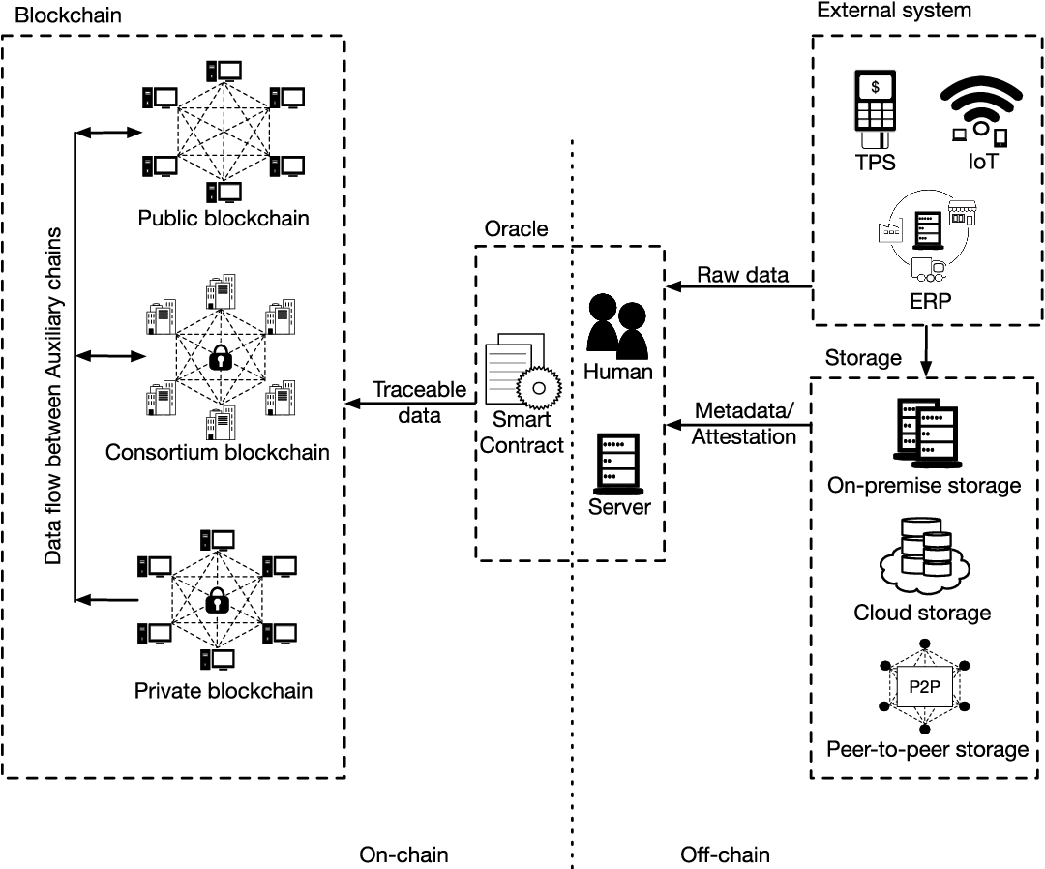

**REQUIREMENT ANALYSIS**

A thorough requirement analysis is essential when considering the implementation of a blockchain-powered library management system. This analysis helps in defining the project scope, understanding user needs, and setting clear objectives. Here's a breakdown of the requirements for such a system:

1. User Requirements:

a. Patron Needs:

- User registration and profile management.

- Ability to browse and search the library's resources.

- Easy access to resource availability, borrowing, and return status.

- Secure and convenient borrowing and returning of resources.

- Notification and alerts for due dates, reservations, and other updates.

- Access to a user-friendly mobile or web interface.

b. Librarian Needs:

- Resource cataloging and metadata management tools.

- Patron management and user activity tracking.

- Interlibrary loan management.

- Reporting and analytics features.

- User support tools for issue resolution.

2. System Requirements:

a. Blockchain Infrastructure:

- Selection of the blockchain platform and consensus mechanism.

- Design of the permissioned blockchain network.

- Scalability and fault tolerance considerations.

b. Smart Contracts:

- Development of smart contracts for resource management and digital rights.

- Integration with other blockchain components.

c. Identity Verification:

- Implementation of user identity verification features.

- Integration with external identity verification systems if necessary.

d. Data Security and Privacy:

- Encryption protocols for sensitive data storage.

3. Library Resource Requirements:

a. Resource Tokenization:

- Unique digital identifiers for each library resource.

- Digital asset management tools for token creation.

b. Metadata and Cataloging:

- Integration with existing cataloging systems.

- Immutable storage of metadata on the blockchain.

- Support for various types of resources, including physical and digital.

c. Digital Rights Management (DRM):

- Integration of DRM features using smart contracts.

- Enforcement of copyright restrictions.

4. Interlibrary Cooperation:

a. Resource Sharing:

- Support for interlibrary loans and resource sharing.

- Automation of resource requests and approvals.

5. Transactions and Records:

a. Transparent Transactions:

- Recording of all library transactions on the blockchain.

- Automation of fines and fees calculations and collections.

6. User Interfaces:

a. Mobile and Web Interfaces:

- Development of intuitive and user-friendly interfaces.

- Search and discovery tools for easy resource access.

7. Integration with Existing Systems:

a. Legacy System Integration:

- Compatibility with existing library management software.

- Data migration and interoperability.

8. Security and Compliance:

a. Data Security:

- Protection of sensitive user data.

- Secure access controls and authentication.

9. Training and Support:

a. User Training:

- Training programs for library staff and patrons.

b. Technical Support:

- Ongoing technical support and issue resolution.

10. Scalability and Performance:

a. Scalability:

- System must be designed to handle an increasing number of users and resources.

b. Performance:

- Ensure that system remains responsive and efficient even during peak usage times.

By conducting a detailed requirement analysis, library management can better plan for the development and implementation of a blockchain-powered system that meets the needs of both library patrons and staff while ensuring security, privacy, and scalability.

Blockchain-Powered library management system

Blockchain network

SMART CONTRACTS

* Catalog Management
* Lending and Borrowing
* Digital Rights Management
* Interlibrary Loans
* Fine and Fee Management
* Inventory Management
* Transaction History
* Patron Reward

LIBRARY MANAGEMENT SERVER

* Integrates with existing library systems. Example, ILS
* Manages blockchain interactions and data updates

USER INTERFACE (UI)

* Patron portal
* Librarian dashboard
* Administrator control panel

EXTERNAL DATA SOURCE

* Patron information
* Catalog and resource information
* Regulatory and compliance data

**PROJECT DESIGN**

**Blockchain Network**: This is the underlying blockchain infrastructure that stores and manages the library's data. It includes the distributed ledger technology and consensus mechanism.

**Smart Contracts**: These are self-executing contracts that automate various library management processes, such as cataloguing, lending, borrowing, and more.

**User Interface (UI)**: The UI components provide access to the system for patrons, librarians, and administrators. They interact with the smart contracts through a user-friendly interface.

**Library Management Server**: This server manages the interaction between the user interface and the blockchain network. It may integrate with existing library systems, ensuring a seamless connection between the blockchain-powered system and the library's other operations.

**External Data Sources**: These sources provide additional data necessary for the system, such as patron information, resource catalogue data, and regulatory information.

This architecture allows for a transparent and efficient library management system powered by blockchain technology. It automates processes, enhances security, and ensures data integrity while improving the user experience for patrons and library staff.

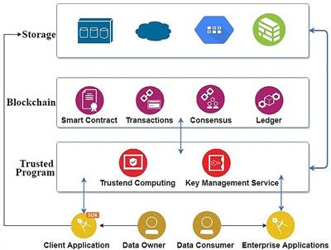

**PROJECT PLANNING AND SCHEDULING**

Similar to circumstances with cybercurrency data management, if a large number of patients and healthcare providers are added to the blockchain, the congestion caused by the huge computational burden can lead to query inefficiencies. The minimum mean propagation time (the average time it takes for a new block to reach most nodes in the network) was 1494.2 s and the minimum mean transaction time in the blockchain was 128.7 s. The results of these experiments pose the question whether the system is based on blockchain technology could meet the need for efficient and timely, billing, or information sharing queries. A second challenge concerns potential injustice and inequity in access and high energy demands. The blockchain uses incentive models to reward participation. In these models, transactions require network currency, such as Bitcoin or Ether. Currency can be earned by mining rewards or transaction fees. Network currencies have real value and they can be used for subsequent activities on the blockchain. The rewards in the blockchain, the cryptocurrency Ether, will be given to care providers as a reward to incentivize them to participate in mining. The Ether blockchain protocol can be used for in-chain activities such as accepting viewing permissions and posting and updating contracts. Such an incentive is likely to cause inequities for lower resourced systems. In a mechanism such as the proof-of-work (POW) blockchain system to obtain network currency, nodes (miners) in the blockchain need to constantly guess a random number (nonce) to obtain the power to generate the next block. If the hash value corresponding to the string obtained by combining the random number and the existing data of the blockchain meets the difficulty value requirements of the blockchain, the node can broadcast its calculation results, obtain the proof of work and the reward (network currency) of the corresponding block. Therefore, POW requires the care provider to perform repetitive calculations using specialized computer hardware until one gets the correct nonce. This energy-intense calculation has very high requirements for computing hardware and energy power, even requiring specialized computer hardware known as application-specific integrated circuits (ASICs) for the mining.

**CODING AND SOLUTIONING**

**Prerequisite**

1 download node.js: Node.js

2 download vs code: https://code.visualstudio.com/download

3 download MetaMask: https://metamask.io/

**Steps to complete the project**

Step 1:

1. Open the Zip file and download the zip file. Extract all zip files

Step 2:

1.Open vs code in the left top select open folder. Select extracted file and open.

2. Select the projectname.sol file and copy the code.

3. Open the remix ide platform and create a new file by giving the name of projectname.sol and paste the code which you copied from vs code.

4. Click on solidity compiler and click compile the projectname.sol

5. Deploy the smart contract by clicking on the deploy and run transaction.

6. select injected provider - MetaMask. In environment

7. Click on deploy. Automatically MetaMask will open and give confirmation. You will get a pop up click on ok.

8. In the Deployed contract you can see one address copy the address.

9. Open vs code and search for the connector.js. In contract.js you can paste the address at the bottom of the code. In export constant address.

10. Save the code.

Step 3: open file explorer

1. Open the extracted file and click on the folder.

2. Open src, and search for utilities.

3. You can see the frontend files. Select all the things at the top in the search bar by clicking alt+ A. Search for cmd

4. Open cmd enter commands npm install npm bootstrap npm start

5. It will install all the packages and after completing it will open {LOCALHOST IP ADDRESS} copy the address and open it to chrome so you can see the frontend of your project

**1. PERFORMANCE TESTING**

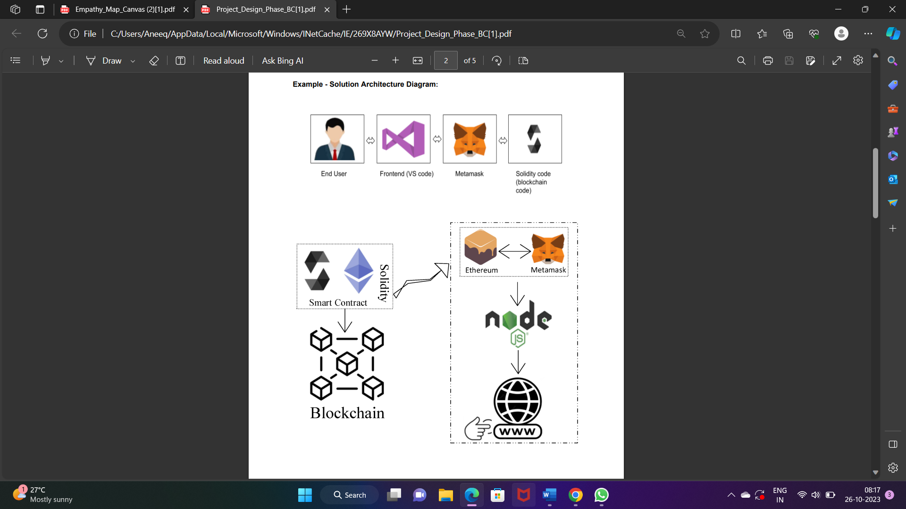

**RESULT**

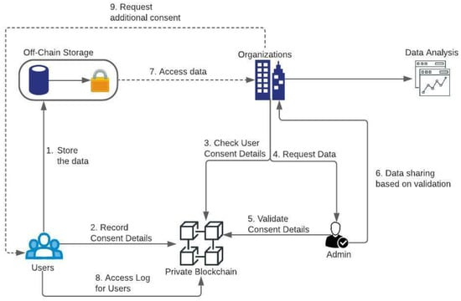

**ADVANTAGES AND DISADVANTAGES**

Blockchain's cryptographic security provides a robust defence against data breaches and unauthorized access to sensitive patron information. It helps protect user privacy and intellectual property rights.: The blockchain ledger ensures that once data is recorded, it cannot be altered or deleted. This transparency and immutability promote trust in library transactions and data integrity. Blockchain facilitates accurate and real-time tracking of library resources, including availability, status, and borrowing history, making it easier for patrons to find and access resources. Smart contracts automate resource lending, returns, and reservation processes, reducing administrative overhead and improving the user experience. Blockchain simplifies and automates interlibrary cooperation, enabling seamless resource sharing, interlibrary loans, and cross-library transactions. The transparent nature of blockchain allows libraries to maintain a public ledger of all transactions, enhancing accountability and reducing disputes.

Implementing a blockchain system can be complex and costly, requiring specialized expertise and resources that some libraries may lack. Blockchain networks can face scalability issues as more participants join the network and the volume of transactions increases. This can impact system performance. Users and staff may need to adapt to the new system, which could be challenging and may require training. Resistance to change is a common issue during system transitions. Compliance with data protection regulations and library standards may be more complex when using blockchain, potentially leading to legal and regulatory challenges. Some blockchain networks, especially those using Proof of Work (PoW) consensus mechanisms, can consume significant amounts of energy, which may not align with sustainability goals. While blockchain provides strong security, some privacy concerns may arise due to the permanence of data on the blockchain. Striking a balance between transparency and user privacy can be challenging.

**CONCLUSION**

In conclusion, the integration of blockchain technology into library management systems represents a promising avenue for the transformation of traditional libraries in the digital age. This innovative approach offers a range of advantages, including enhanced security, transparency, and automation of processes, ultimately enriching the library experience for both patrons and staff. Blockchain-powered library management systems bring several key benefits, such as the ability to secure patron data and intellectual property rights, streamline resource tracking and transactions, and foster seamless interlibrary cooperation. By recording transactions on an immutable ledger, libraries can build trust and accountability while automating essential tasks like borrowing, returning, and reserving resources. However, it's important to acknowledge the challenges and considerations that come with implementing such a system. Complexities in setup, cost, scalability, and user adaptation may pose obstacles for libraries, and navigating regulatory compliance and privacy concerns is essential. Additionally, energy consumption and interoperability must be carefully managed. In the evolving landscape of information and knowledge management, blockchain technology has the potential to position libraries as even more integral knowledge hubs by addressing the demands of the digital era. As libraries explore the adoption of blockchain-powered systems, they must tailor their approach to their unique needs, resources, and objectives to ensure a successful transition. As technology continues to advance, blockchain offers a path for libraries to continue their vital role as stewards of knowledge in an increasingly digital world.

**APPENDIX**